Laycee Glass
NVM4 Task 2
Data Mining I
2/4/24
Western Governors University

NVM4 Performance Assessment, Task 2

Student Information
Student Name: Laycee Glass
ID Number: 001896026
Date: 2/4/24

Part 1. Research Question

A1. Research Question
The research question chosen for this task was the following: Can we predict the total charge of a patient during a hospital admission?

A2. Goal of Analysis
The goal for this analysis was to identify which factors influenced total charge of a patient during their hospital stay.

Part II: Method Justification

B1. Prediction Method and Expected Outcomes
I chose to use Ridge regression for this task because the dependent variable, TotalCharge, was a continuous variable. Ridge utilizes a “regularization term” which helps to prevent overfitting of the data, as well as standardization of least squares to shrink the regression coefficients. This makes for a more stable model.

B2. Assumption
One key assumption of Ridge regression is a linear relationship between the independent variables and the dependent variable. If there is not a linear relationship, the predictions from the model may not be accurate (Team, 2024).

B3. Packages/Libraries
For this task, a number of packages and libraries were used. They were as follows:

- pandas: handling of data
- numpy: performing numerical computations/operations
- seaborn: creating visualizations
- sklearn: scaling, splitting of data, regression, accuracy calculations

Part III: Data Preparation

C1. Preprocessing Goal
The main goal for preprocessing in our case was variable encoding. Ridge requires numerical inputs, so the categorical variables needed to be re-expressed before training the model.
Another important goal was feature scaling. This was to ensure all variables contributed equally to the regression, meaning they all had equal influence.

C2. Variables
The variables included in the task were the following:

Dependent variable:
- TotalCharge (continuous)

Independent, categorical variables:
- Gender
- ReAdmis
- HighBlood
- Stroke
- Complication_risk
- Overweight
- Arthritis
- Diabetes
- Hyperlipidemia
- BackPain
- Anxiety
- Allergic_rhinits
- Reflux_esophagitis
- Asthma
- Services

Independent, continuous variables:
- Age
- Income
- VitD_levels
- Doc_visits
- Initial_days

C3. Data Preparation
To prepare the data, many of the same steps from previous courses were used. This included identifying nulls and outliers. No nulls were present and the outliers were retained as these values were ‘expected.’ The code for this is shown below:
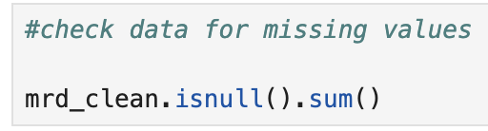

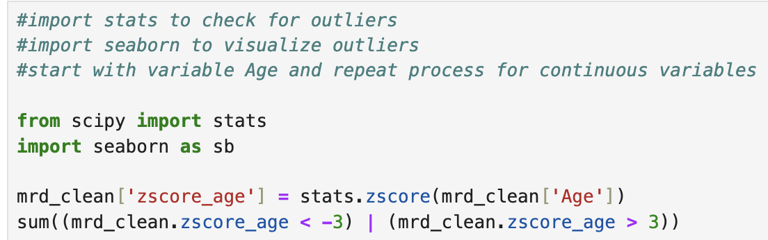

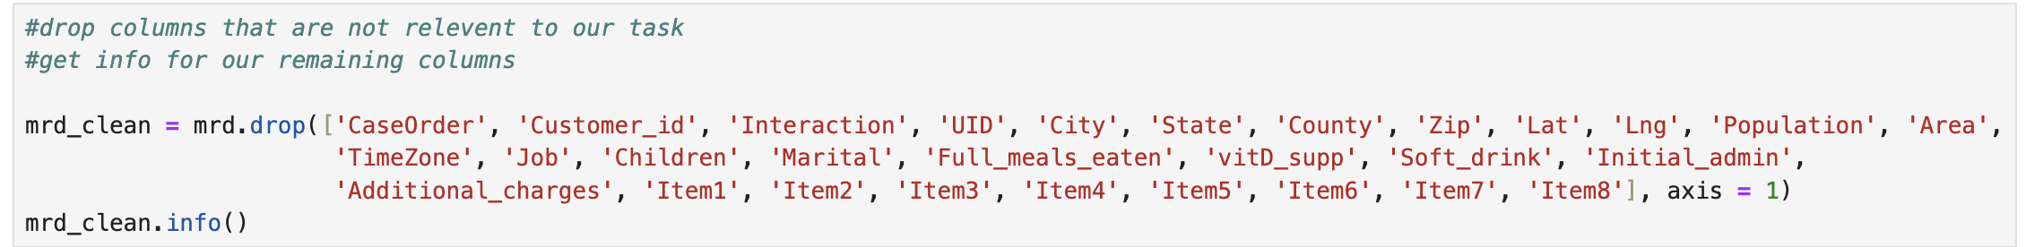
Columns that were not relevant to our task were dropped. The code for this is shown below:
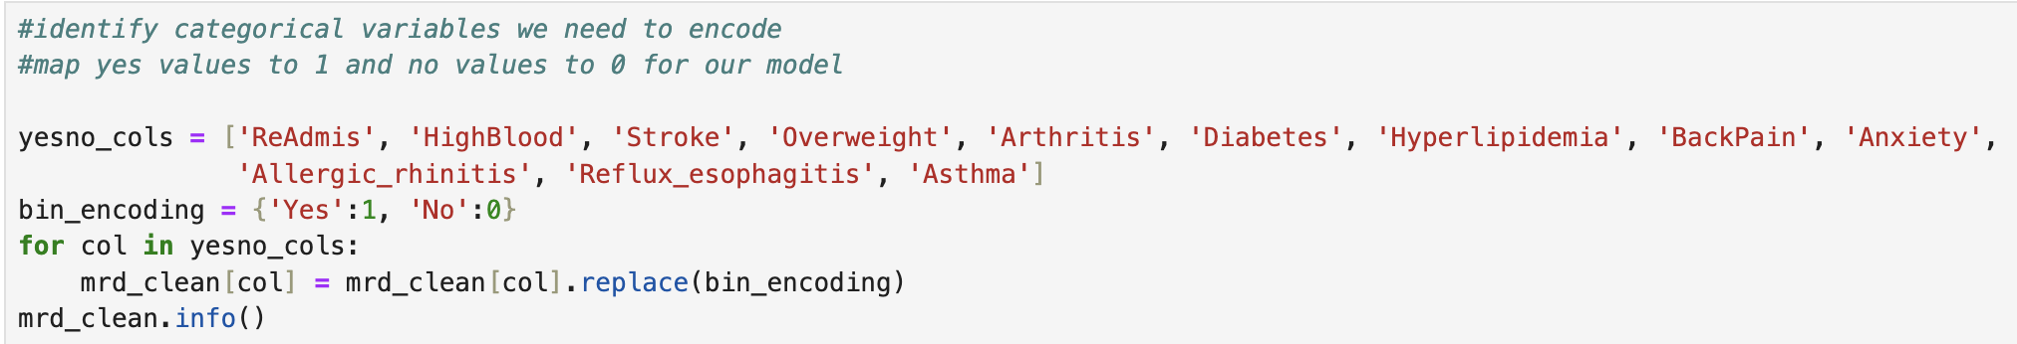
Categorical variables that had Yes/No values were then encoded to 1/0 values. The code for this is shown below:

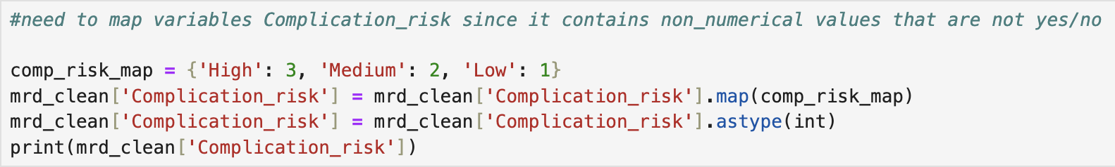
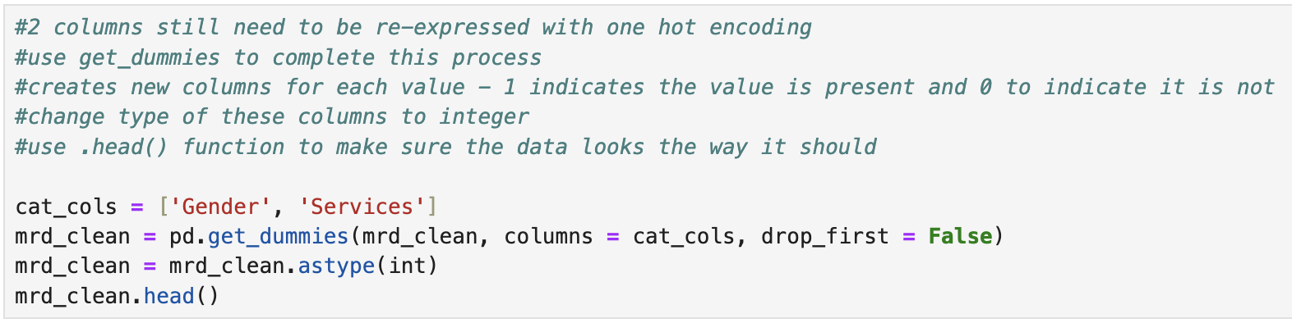
Complication_risk was also encoded because of its values, as they needed mapped to integer values. One hot encoding was then used to re-express the other categorical variables that did not have Yes/No values, such as Gender. The code for this is shown below:
The continuous variables were grouped and then scaled using StandardScaler() since it puts all features on the same scale. The code for this is shown below:

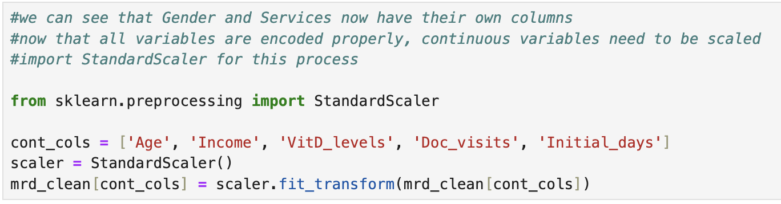
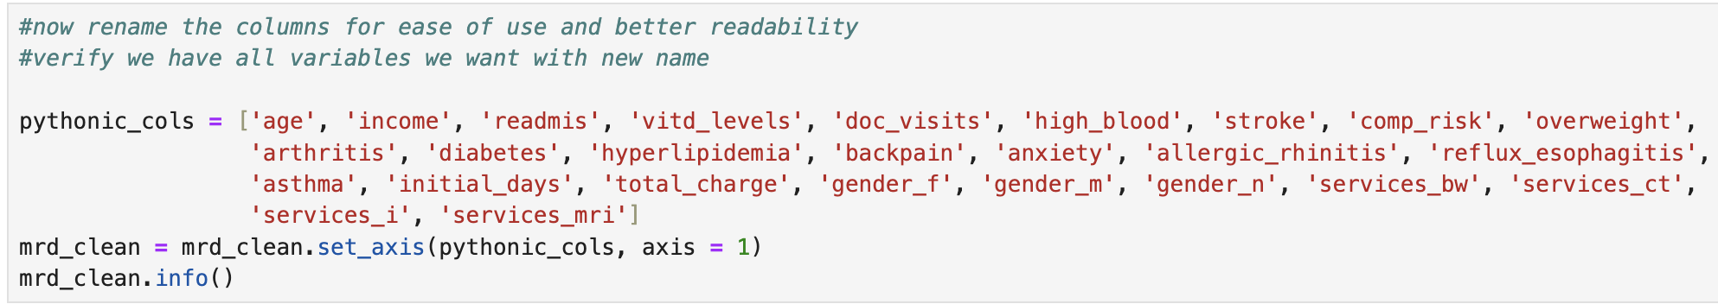
Columns were also renamed for ease of use and readability. The code for this is shown below:

C4. Copy of Cleaned Data
The cleaned dataset was then exported to its own csv file, attached with this paper. The code for this is shown below:
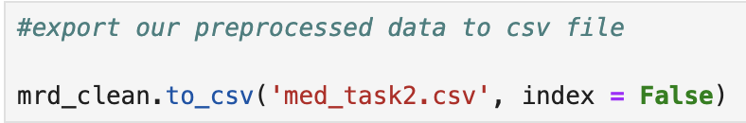

Part IV: Analysis

D1. Training and Testing Sets
As part of the regression, the data was split into training and testing sets at a 70/30 split. These sets were then exported to their own csv files, submitted alongside this paper. The code for splitting of the data and its subsequent exportation is shown below:

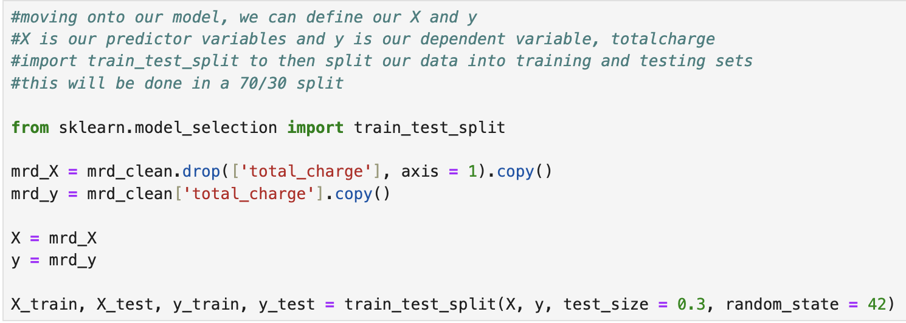
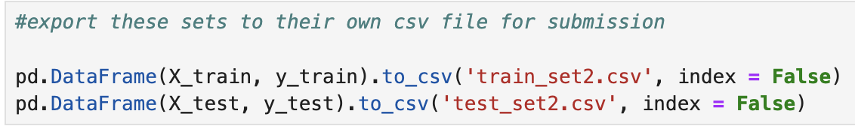

D2. Analysis Technique
As stated before, Ridge regression was the prediction model for this task. Before being able to run the model, I had to identify the optimal alpha value. I used a set of alphas, ranging from 0.1 up to 10000.0. These were then run and scored to find the best value. This ended up being 0.1.

D3. Code
The following code was used to perform the previously stated action of finding the best alpha:
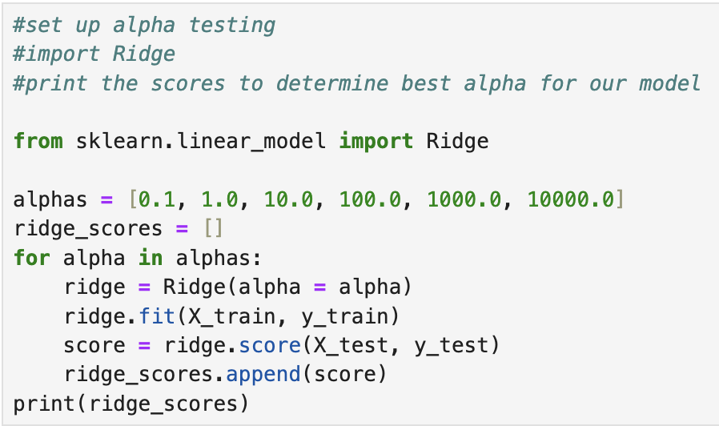

Once the optimal alpha had been identified, I then ran the model on the training data using such. The code for this shown below:

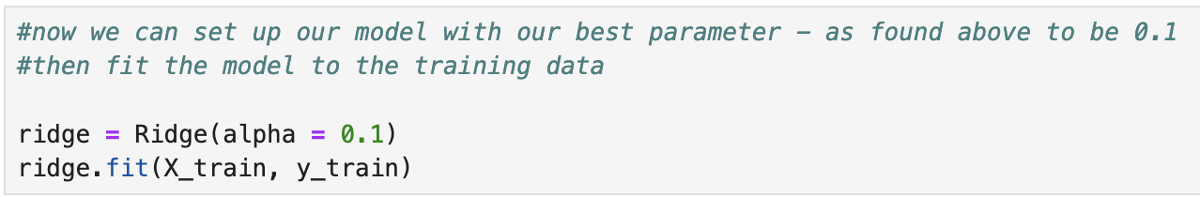
Part V: Data Summary and Implications

E1. Accuracy and MSE
For assessing accuracy of the model, I created accuracy scores for both the training set and the testing set. These scores, along with the code to create them, is shown below:
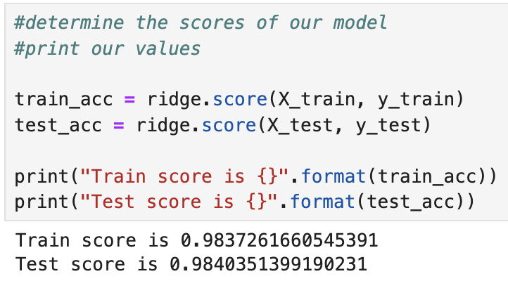

As we can see, the scores were incredibly high for both, right around 0.984. This means the model explains 98.4% of variance in the data, which indicates a relatively strong performance.
The mean squared error (MSE) and root mean squared error (RMSE) were also calculated for the model. These values, along with code to calculate them, is shown below:
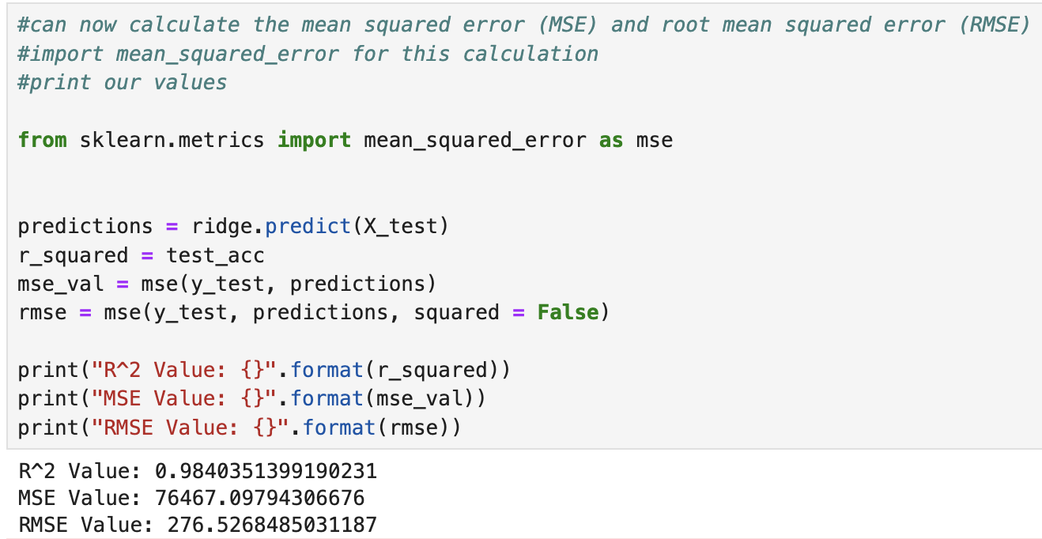

The MSE and RMSE values, at first glance, seemed astronomical. This may lead us to believe that the model does not perform well. However, upon further investigation into our data, we can see the dependent variable deals with costs well into the thousands. So, the RMSE indicated an average error of $276.52 in the predictions, which was actually only 5% of the cost on average.
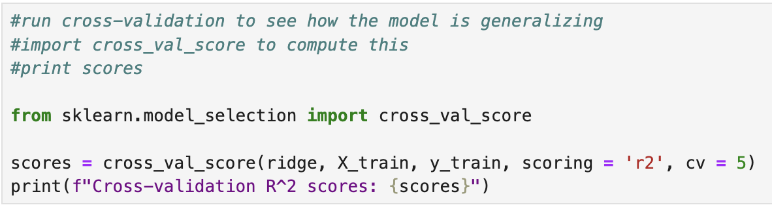
Even further, I went ahead and ran cross-validation scores on the model. The scores had an average of 0.983, meaning the model was generally reliable as the scores were very consistent across multiple test sets. The code for this is shown below:

E2. Results and Implications
As stated in E1, the model performed well based on accuracy and MSE/RMSE metrics. The accuracy scores of 0.983 and 0.984 were close to 1, where 1 indicates a perfect model.
The MSE and RMSE, whilst larger in value than anticipated, also indicated a good performance of the model after considering the scale of the dependent variable, as well calculating the cross-validation scores (Frost, 2023).
Overall, this suggests our model performs well, and the model is accurate at predicting total charge for patients.

E3. Limitations of Analysis
The model, as is the case by itself, lacks context as interactions between variables isn’t modeled. Certain conditions, treatments, and insurances may interact in ways that impact charges significantly. For example, having a stroke and surgery could lead to higher costs due to complications, but the regression model treats these as independent effects (Dsouza, 2023).

E4. Course of Action
In general, acquiring more data is often what I recommend for these tasks, and this one is no different. Getting more data, especially about insurances, would help the model. As insurances play a huge role in determining costs, this data could help account for these cost variations between patients.
Also, I would suggest using this model in conjunction with other models. This would be highly beneficial because while Ridge is great at reducing multicollinearity, not all data is linear in nature (especially real world healthcare data!). Using random forests to better capture complex relationships and neural networks to help with feature interaction would create a better overall picture for the hospital systems, which, in turn, could help with cost planning.

Part VI: Demonstration

F. Panopto Recording
A Panopto recording showing execution and functionality of the code has been submitted with this paper.

G. Code Sources
D209 DataCamp Courses

H. Text Sources
Dsouza, L. F. (2023, July 28). Lasso vs. Ridge regression in aviation: Use cases and limitations. Medium. https://medium.com/@lynnfdsouza/lasso-vs-ridge-regression-in-aviation-use-cases-and-limitations-e9fad1efd9fb#:~:text=Inability%20for%20Feature%20Selection%3A%20Unlike,each%20feature%20in%20the%20model.
Frost, J. (2023, May 28). Mean squared error (MSE). Statistics By Jim. https://statisticsbyjim.com/regression/mean-squared-error-mse/
Team, G. L. E. (2024, September 2). What is ridge regression?. MyGreatLearning. https://www.mygreatlearning.com/blog/what-is-ridge-regression/

